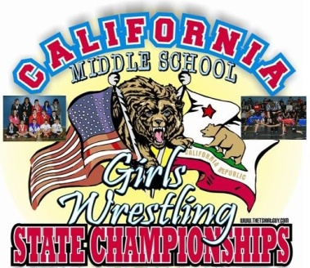
RELEASE AND HOLD HARMLESS AGREEMENT
PLEASE READ THIS FORM CAREFULLY and beware while registering to compete and train, you are releasing your child/minor from all claims/injuries and reimbursement for medical bills your child might sustain participating for California Girls Middle School State Wrestling Championships.
I______________________(please print parent/guardians name) recognize and acknowledge that there are certain risks of physical injury to participants in the program and I agree to assume full risk of any such injuries, damages or loss regardless of severity, which I or my child/ward may sustain resulting from California Girls Middle School State Wrestling Championship participation.
I waive and relinquish all claims I or my child/ ward may have against discharge Ukiah High School, SW Academy Inc., coaches and its officers and Ukiah Unified School District resulting from California Girls Middle School State Wrestling Championship participation & hereby fully release and Windsor High School, SW Academy Inc., coaches and its officers and Ukiah Unified School District from any/all claims from injuries, damage or loss which I or my child/ward may have or which may accrue to me or my child/ward because of CGMSSWC WRESTLING participation.
I further agree to indemnify and hold harmless discharge Ukiah High School, SW Academy Inc., coaches and its officers and Windsor Unified School District, or from any/all claims from injuries, damage or losses sustained by me or my child/ward because of California Girls Middle School State Wrestling Championship participation.
I have read and fully understand the above program details and waive and release all claims.
My child, ____________________________, is in good physical health, is able to, and has my permission to participate in the wrestling program.
------------------------------------------------------------------------------------------------------------------------------------------------------------------------------------------------------------------------------------------
Student-Athlete Name Printed Clearly ____________________________________________________
_______________________________ Student Athlete’s Signature ________ Date
______________________________ Parent/Guardian Signature ________ Date
After signing this form please make a copy of it for your records and return the original on the day of the event

