2013.09.26
3rd Annual Philippines Wrestling Showcase (Vallejo, California, USA)
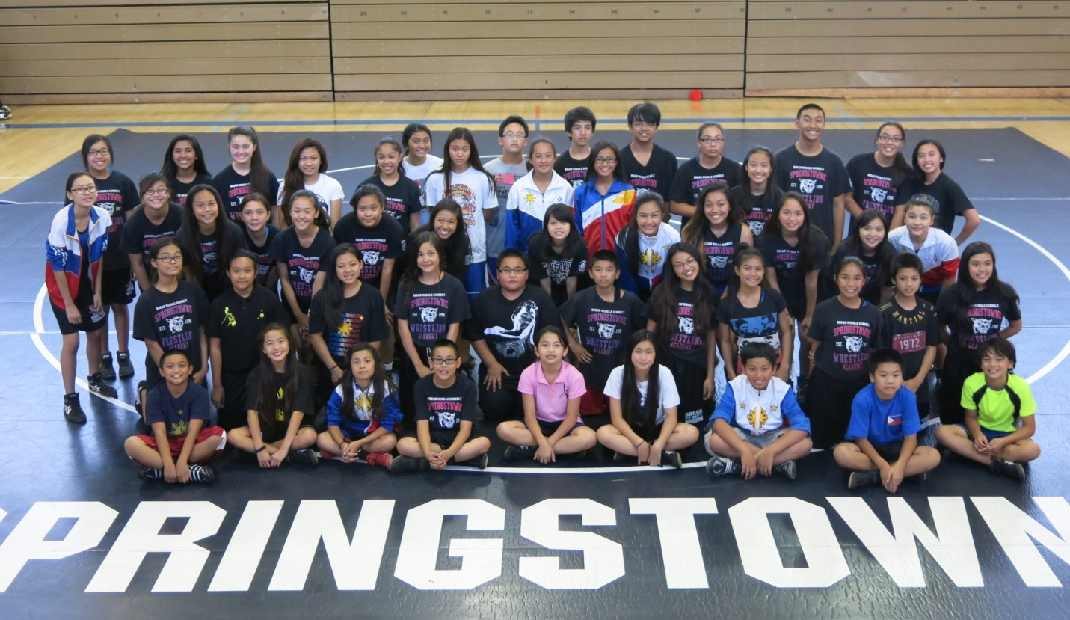
Middle School Showcase Participants
The 3rd Annual Philippines Wrestling Showcase in Vallejo, CA, USA saw some fantastic grappling occur on September 26, 2013. A bit of WAP history even came to light linking a current wrestler to an amazing figure of the WAP’s past.
The middle school folkstyle division was a highly spirited contest, thanks in part to an all-time high number of participants with 56. The home team host Springstowne Wildcat Wrestling Academy brought 54 competitors to the event, which saw Lady Wildcats Joanne Cabanlit and Jasmine Capiral become the event’s 1st 3-year participants. The pair wrestled at the Inaugural event in 2011 and each subsequent one since. Nearby Benicia Middle School also brought two highly skilled wrestlers in Tara and Basil Othman, who went a combined 5-1 on the day.
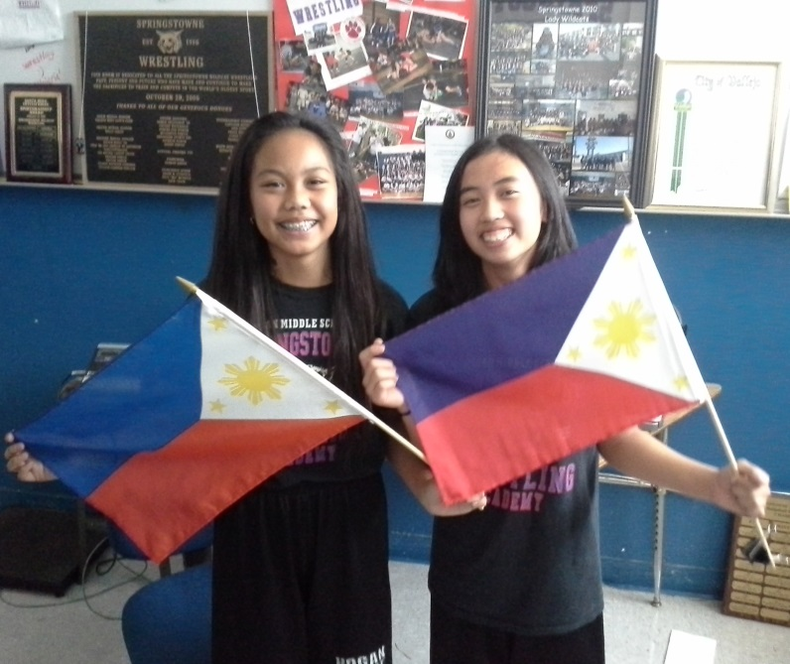
Jasmine Capiral and Joanne Cabanlit Became The 1st 3-Year Middle School Participants
The High School/Open saw a dip in the number of participants with only 11 competitors registered for the event, but the competition was fierce throughout including an amazing storyline as the exclamation point to a terrific evening
Co-Director Jeremiah Esguerra and newly coined “Mr. Showcase” extended his All-Time Record Showcase win total to 5 in 3 years, by scoring both Freestyle and Greco wins vs the physically imposing Damien Reyes. On the girl’s side, the crowd was treated to a battle of the titans between Ricki Liang and Shelly Avelino, two of the all-time greats from the Springstowne program. The two were deadlocked 4-4 at the end of the 1st period, before Liang utilized her experience as a two-time member of USA Wrestling’s Team California to pull out the win.
The most intriguing story of the night was Brandon Basa, who traveled close to 200 miles from Carson City, Nevada to compete in the HS/Open. His grandfather was Jose Ma Basa III, who was appointed by President Marcos to train and prepare Philippine wrestlers to compete at an event in Edmonton, Canada in the 1970’s. The family even had a vintage WAP warm up top on hand. (See Pics Below)
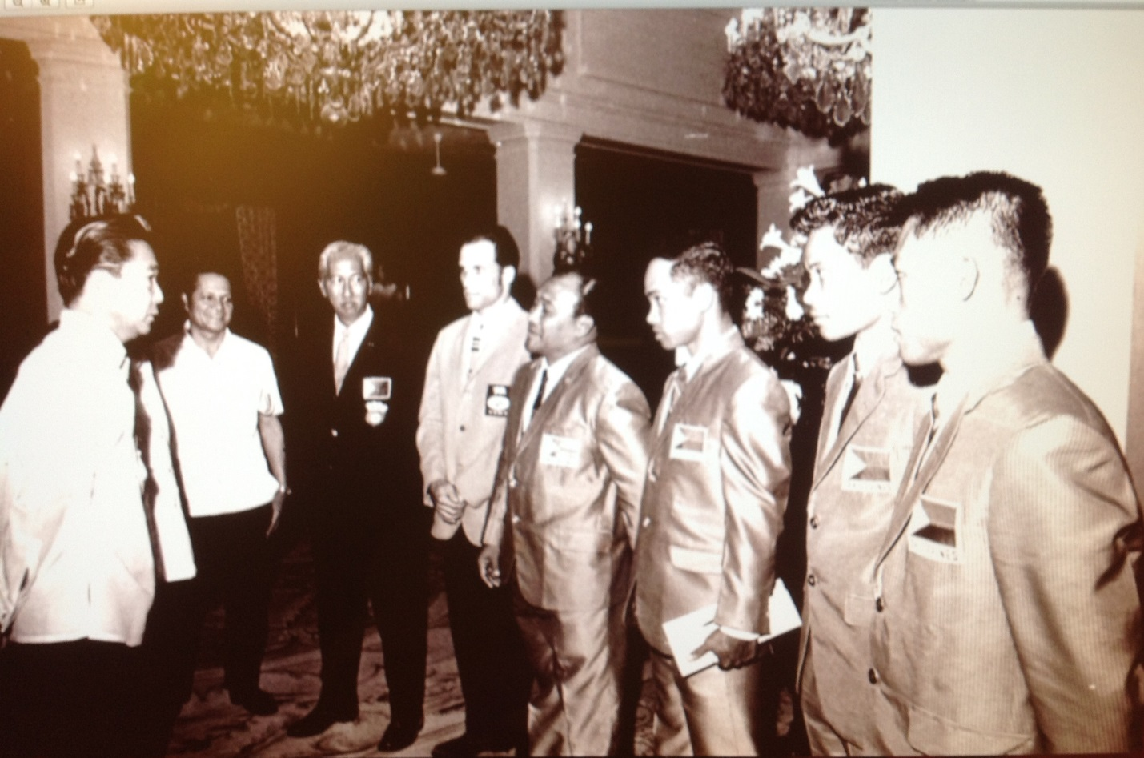
President Marcos @ left ~ Jose Ma Basa III in black suit ~ WAP wrestlers @ right
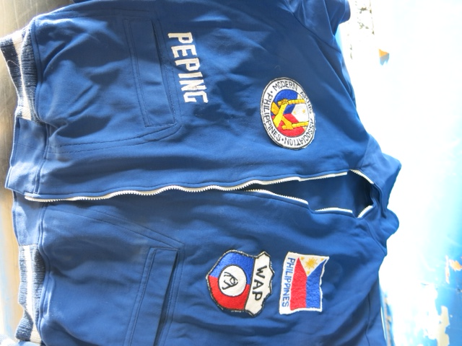
A Vintage WAP Warmup Jacket Courtesy Of The Basa Family

Brandon lived true to the family’s wrestling heritage as he scored 2 freestyle wins and one Greco win on the night.
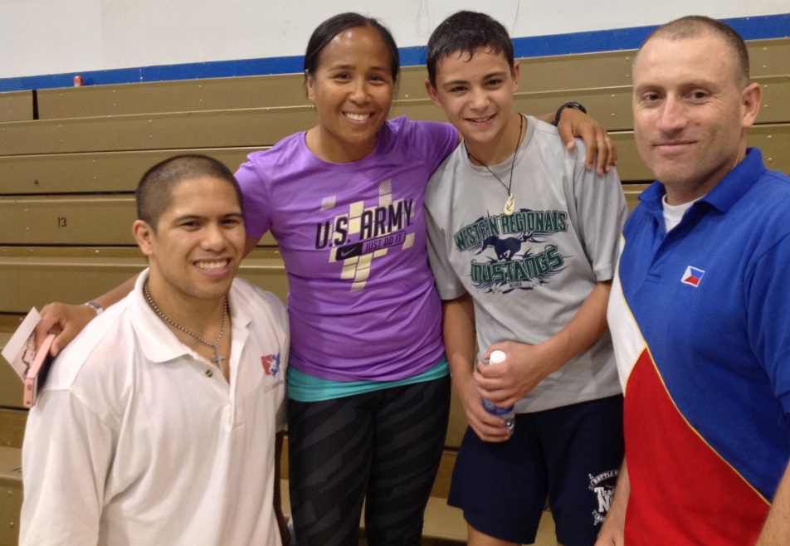
Brandon Basa With Event Directors Jeremiah Esguerra, Julie Gonzalez and Jason A. Guiducci
Following up last year’s success of the singlet donation program, this year’s Showcase will be donating 30 singlets to be split amongst three clubs identified by WAP President Albert Balde. The recipients will be Baguio, Ifugao and Antique. Pictured below are a number of Springstowne Wildcats holding the singlets.
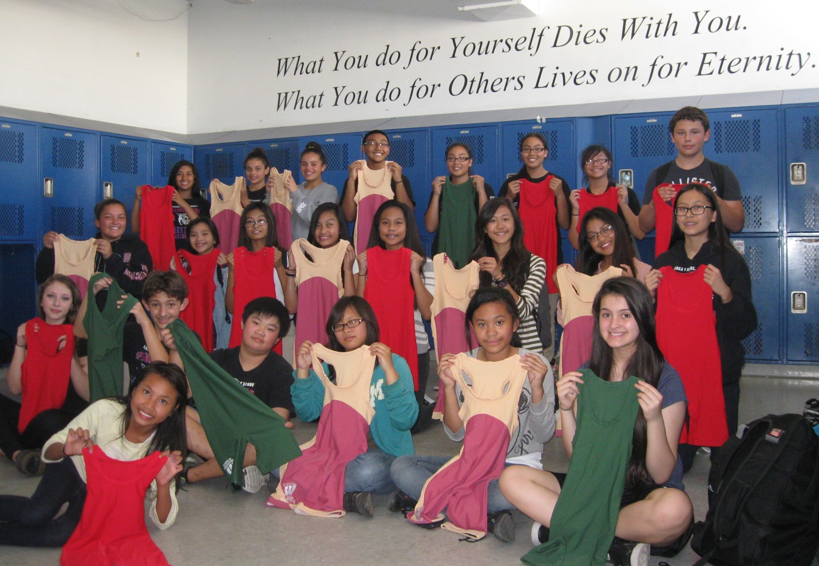
3rd Annual Philippines Wrestling Showcase Results:
Middle School Folkstyle
• Maiya Alemania(Springstowne) defeated Kaitlin Cuevas (Springstowne)
• Trinity Jade Castillo (Springstowne) defeated Arianna Perez (Springstowne)
• Miliani Rose Jimenez-Diolanto (Springstowne) pinned Elysia Tulabut (Springstowne)
• Meriel Ferrer (Springstowne) defeated Marcelina Valmonte (Springstowne)
• Precious Bautista (Springstowne) pinned Angel Mendoza (Springstowne)
• Alyssa Geronimo (Springstowne) defeated Shailenne Cabuloy (Springstowne)
• Basil Othman (Benicia) pinned Jhaycen Quinones (Springstowne)
• Tara Othman (Benicia) defeated Justin Pascua (Springstowne)
• Rylee Cruz-Smith (Springstowne) pinned Angela Abuda (Springstowne)
• Hazel Solar (Springstowne) defeated Samantha Dollete (Springstowne)
• Kiara Valle (Springstowne) defeated Jasmen Caceres (Springstowne)
• Lillian Parungao (Springstowne) pinned Jacqueline Nebres (Springstowne)
• Chentelle Wise (Springstowne) pinned Fiona Pasion (Springstowne)
• Elisabeth Franco (Springstowne) defeated Joanne Cabanlit (Springstowne)
• Mark Ryan Jimenez-Diolanto (Springstowne) defeated Basil Othman (Benicia)
• Tara Othman (Benicia) defeated Bianca Holman (Springstowne)
• Leika Lopez (Springstowne) defeated Carmille Lobusta (Springstowne)
• Caesha Gemo (Springstowne) defeated Kera Arzadon (Springstowne)
• Ariana Danao (Springstowne) defeated Nicole Ausa (Springstowne)
• Kaelin Pasibe (Springstowne) pinned Rachel Bacnotan (Springstowne)
• CJ Fernandez (Springstowne) defeated AJ Miranda (Springstowne)
• Esai Contreras (Springstowne) defeated Christian Carino (Springstowne)
• Mark Deguzman (Springstowne) defeated CJ Carino (Springstowne)
• Basil Othman (Benicia) pinned Gerrell Castro (Springstowne)
• Tara Othman (Benicia) defeated Tatiana Boyd (Springstowne)
• Christian Carino (Springstowne) defeated AJ de Vera (Springstowne)
• Daphne Rio (Springstowne) pinned Rachel Rio (Springstowne)
• Jared Perez (Springstowne) wins unopposed
• Marjorie Soy (Springstowne) pinned Aileen Torralba (Springstowne)
• Ian Hadlocon (Springstowne) pinned De Andric Sarmiento (Springstowne)
• Jasmine Capiral (Springstowne) pinned Ariana Danao (Springstowne)
• Paige Hardgen (Springstowne) defeated Tatiana Boyd (Springstowne)
HS/Open Freestyle
• Brandon Basa (Carson City) pinned Kyle Creech (Benicia)
• Jeremiah Esguerra (American Canyon) defeated Damien Reyes (American Canyon)
• Jobel Cabigting (Vallejo) pinned Mason Boutain (Vallejo)
• Marlon Cereca (Vallejo) pinned Michael Lim (Daly City)
• Ricki Liang (Vallejo) defeated Shelly Avelino (Vallejo)
• Brandon Basa (Carson City) pinned Derek Reyes (Vallejo)
HS/Open Greco
• Jeremiah Esguerra (American Canyon) defeated Damien Reyes (American Canyon)
• Jobel Cabigting (Vallejo) defeated Marlon Cereca (Vallejo)
• Brandon Basa (Carson City) pinned Kyle Creech (Benicia)
For More Information About The Philippines Wrestling Showcase Host Organization ...
Visit Them On The Web!
